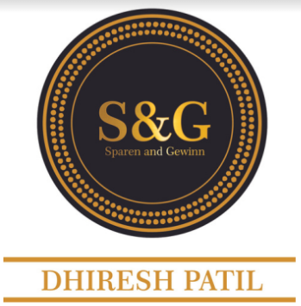

**SPAREN & GEWINN**

**C O N S U L T I N G**

Please find the details of the offer as discussed during Live webinar

1. Internationally accredited Adv Lean Six Sigma Green Belt training & certification

2. Internationally accredited Adv Lean Six Sigma Black Belt training & certification

3. Minitab mastery with practice access of Minitab software.

4. Lean Practitioner Certification Course

5. Basic & Advanced Statistics Course

6. EBook Library of 100+ books on Lean & Six Sigma and other methodologies.

7. Masterclass Archive- Collection of all Live coaching sessions

8. Lean Six Sigma with Python

9. 24/7 access to recorded courses

10. Every week 2 Live coaching sessions from Dhiresh sir.   
Recording available if you miss.

11. Mentor support in project implementation through hot line number

12. Special focus on personal excellence like Communication skills, leadership skills, productivity improvement etc.

Please find the link for **e-Book:** <https://bit.ly/3ddlV6g>

Please find the link for **YB Content**: <https://bit.ly/3d7xoUM>

**Feedback form:** <https://forms.gle/RsWBygMDnEuF6VWf6>

For any queries **email** to [admin@sparengewinn.com](mailto:admin@sparengewinn.com)

**Dhiresh Patil**

Co-Founder & CEO- Sparen & Gewinn Consulting.

<https://sparengewinn.com>

**WhatsApp:** [+91-9930095248](https://wa.me/919930095248) [+91-9930595248](https://wa.me/919930595248)

*Click above number to send WhatsApp*